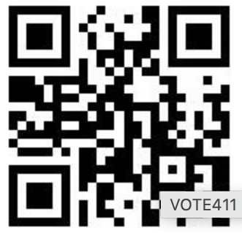

**Michigan Election Dates**

**Michigan Election Dates**

**Michigan Election Dates**

Voting Locations &

Candidate Info

VOTE411.org

Voting Locations &

Candidate Info

VOTE411.org

**Michigan Election Dates**

Statewide Primary

In person Early Voting

Sat., July 27, 2024 - Sun., Aug. 4, 2024

Election Day - Tues., Aug. 6, 2024

Presidential & Statewide Election

In person Early Voting

Sat., Oct. 26, 2024 - Sun., Nov. 3, 2024

Election Day, Tues., Nov. 5, 2024

Statewide Primary

In person Early Voting

Sat., July 27, 2024 - Sun., Aug. 4, 2024

Election Day - Tues., Aug. 6, 2024

Voting Locations &

Candidate Info

VOTE411.org

Voting Locations &

Candidate Info

VOTE411.org

Presidential & Statewide Election

In person Early Voting

Sat., Oct. 26, 2024 - Sun., Nov. 3, 2024

Election Day, Tues., Nov. 5, 2024

Statewide Primary

In person Early Voting

Sat., July 27, 2024 - Sun., Aug. 4, 2024

Election Day - Tues., Aug. 6, 2024

Statewide Primary

In person Early Voting

Sat., July 27, 2024 - Sun., Aug. 4, 2024

Election Day - Tues., Aug. 6, 2024

Presidential & Statewide Election

In person Early Voting

Sat., Oct. 26, 2024 - Sun., Nov. 3, 2024

Election Day, Tues., Nov. 5, 2024

Presidential & Statewide Election

In person Early Voting

Sat., Oct. 26, 2024 - Sun., Nov. 3, 2024

Election Day, Tues., Nov. 5, 2024

