I PLEDGE TO VOTE

☐ I registered to vote today!

☐ I’m already a registered voter!

☐ I will register to vote when eligible!

Information will only be used for voter education purposes and will not be sold or given to any organizations.
I will vote on Election Day to stand up for
what matters most to me, my family and
my community.

Please print information below:
Full Name
Cell phone#
Email

City____________________________________
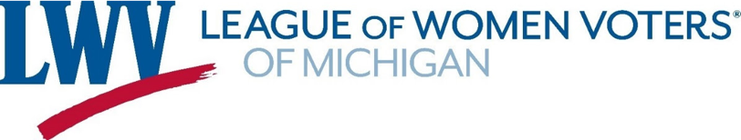
I PLEDGE TO VOTE

☐ I registered to vote today!

☐ I’m already a registered voter!

☐ I will register to vote when eligible!

Information will only be used for voter education purposes and will not be sold or given to any organizations.
I will vote on Election Day to stand up for
what matters most to me, my family and
my community.

Please print information below:
Full Name
Cell phone#

Email

